Name: ______________________________________ | Date: ___________________

Free body diagrams for collisions with and without cushioning structures

Collision condition & system diagram | Free body diagrams
Nothing between the colliding objects

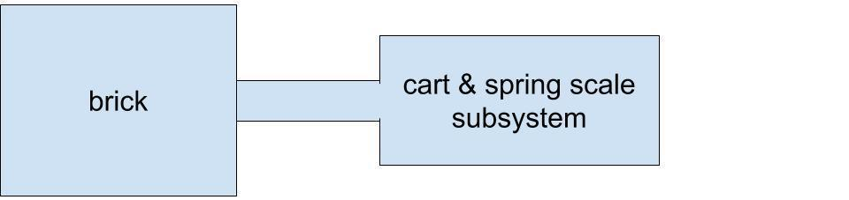

1 ring on either object

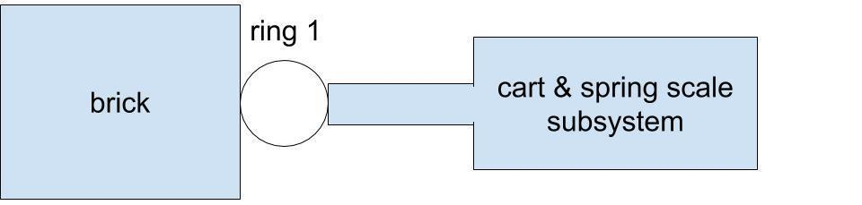

2 rings on either object

